Nicholas Judson

CMPT 220L-203

Professor Arias

01/23/2018

**Setup Java**

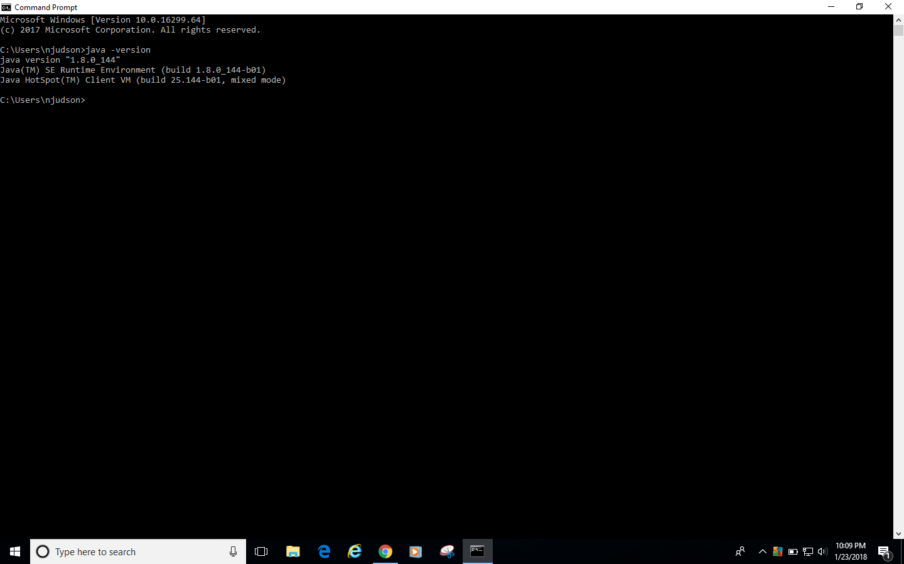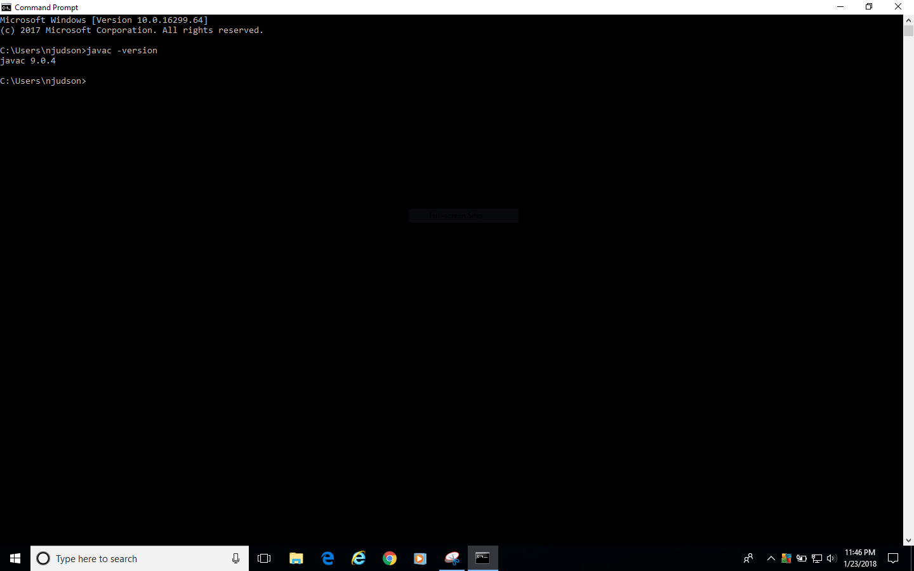

**Create an Account on Kattis**

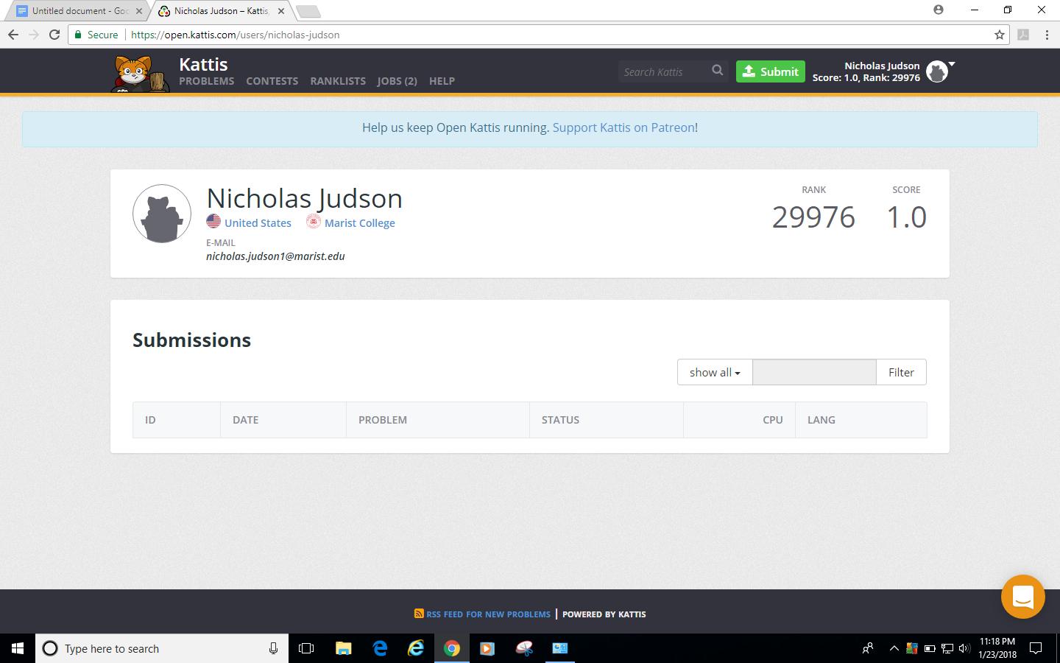

**Create an Account on GitHub**

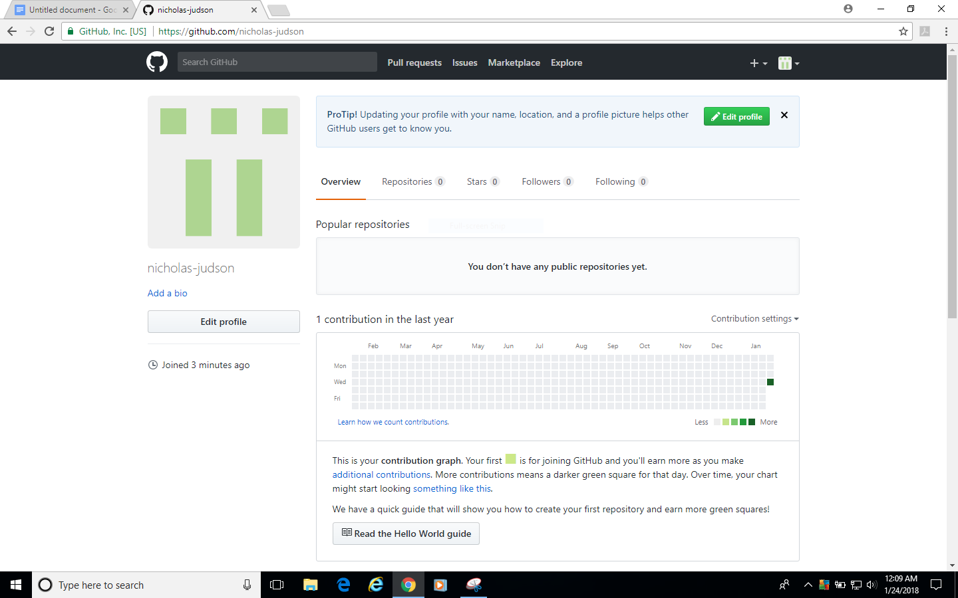

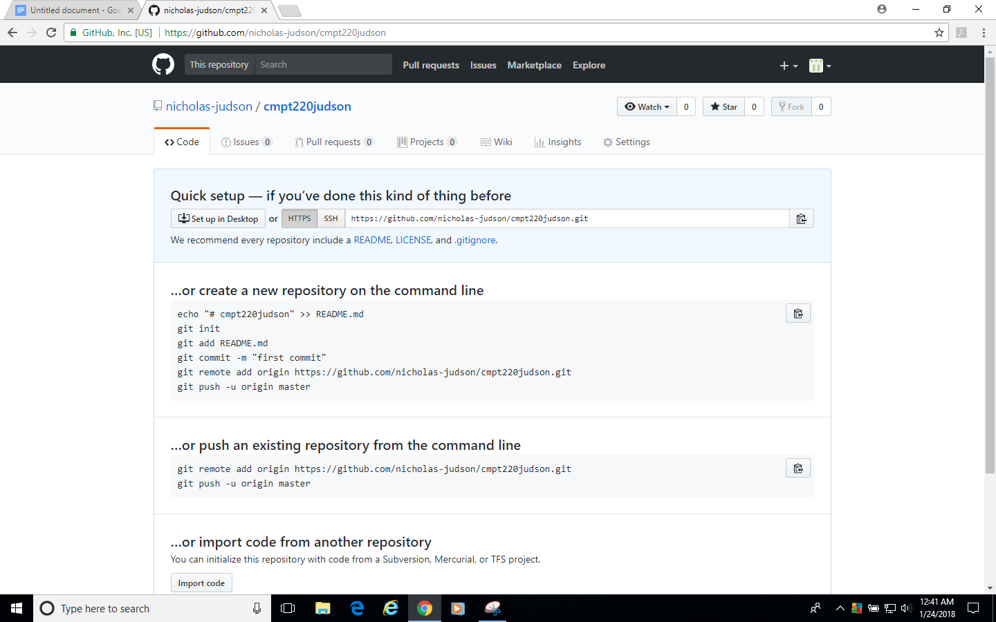

https://github.com/nicholas-judson/cmpt220judson.git